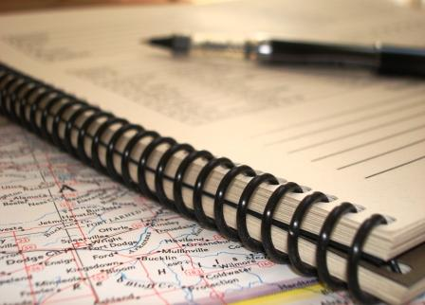

Memoirs of Me
Today I..
_____________________________________________________________________________________________________________________________________________________________________________________________________________________________________________________________________________________________________________________________________________________________________________________________________________________________________________________________________________________________________________________________________________________________________________________________

This morning when I woke up I...
________________________________________________________________________________________________________________________________________________________________________________________________________________________________________________________________________________________________ ________________________________________________________________________ ________________________________________________________________________________________________________________________________________________________________________________________________________________________________________________________________________________________________________________________________________________________________________________________________________________________________________________

After lunch I...
________________________________________________________________________________________________________________________________________________________________________________________________________________________________________________________________________________________________________________________________________________________________________________________________________________________________________________________________________________________________________________________________________________________________________________________________________________________________________________________________________________________________________________________________________________________________________________________________________________________
Later in the afternoon I...
________________________________________________________________________________________________________________________________________________________________________________________________________________________________________________________________________________________________________________________________________________________________________________________________________________________________________________________________________________________________________________________ ________________________________________________________________________________________________________________________________________________________________________________________________________________________________________________________________________________________________________________________________________________________________________
In the evening I...
________________________________________________________________________________________________________________________________________________________________________________________________________________________________________________________________________________________________________________________________________________________________________________________________________________________________________________________________________________________________________________________________________________________________________________________________________________________________________________________________________________________________________________________________________________________________________________________________________________________

( exercise taken from http://www.michigan.gov/documents/mde/lm_2011_MR_GoldfishProgrammingGuide_360492_7.pdf)

